Help sheet for creating a Standard Entry on the App
Fill this sheet in to create an App entry with one photo. It is typically used for a business. Don’t use this for a trail.
It's easy to create an Entry—it will take 10-15 minutes. This is best done on a desktop or laptop computer (using a mobile phone may frustrate you).

Entry Information:
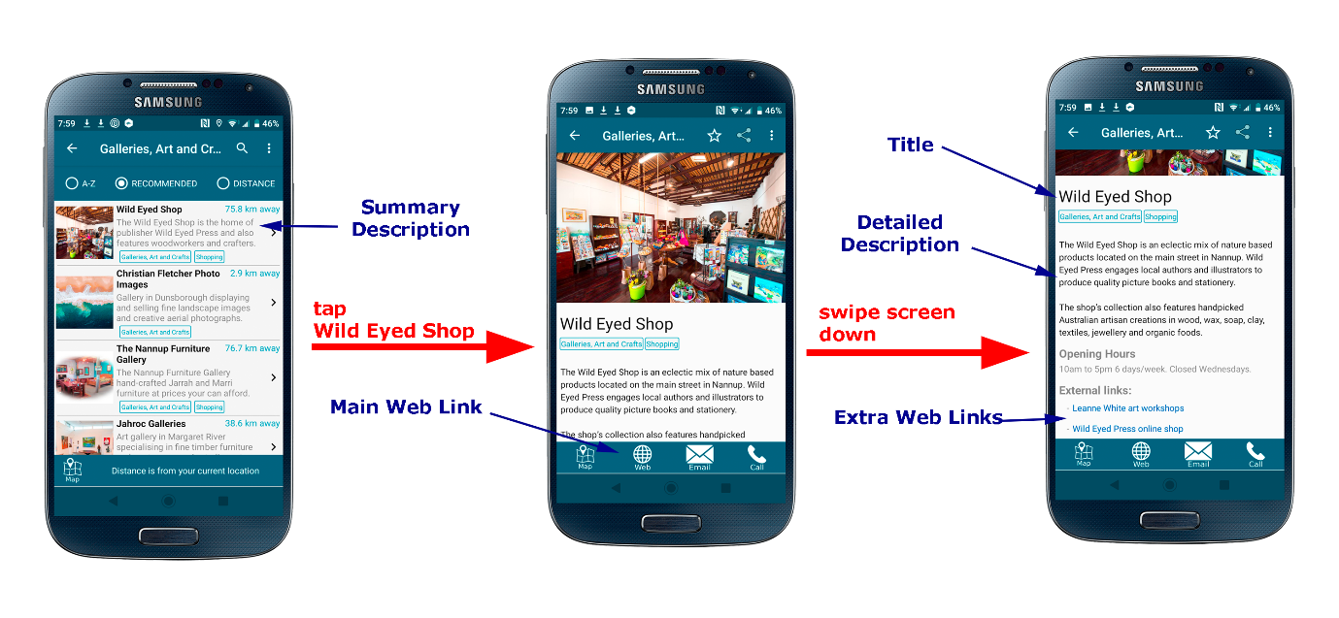

Title
- Title of the Entry. For example, “Nannup Furniture Gallery” or “Barrabup Pool”

Detailed Description

- Maximum 700 or so characters.
- Do not include phone numbers, email addresses, opening hours or web links here. These will be entered elsewhere and associated with buttons on the phone’s screen.
- Do not include directions to get to the business or place. The map button will show users how to get there.

Main Web Link
- Your main website link. This is the website page that will open when the “Web” button is tapped.
- For example, “https://wildeyedpress.com.au/pages/the-wild-eyed-shop”
- Optional – you may leave this box empty if you have no website

Email
- Your email address. This is used when the “Email” button is tapped.
- Optional – you may leave this box empty if you wish. If it is empty the “Email” button will not be shown.

Phone Number
- Your phone number. This is used when the “Call” button is tapped.
- Optional – you may leave this box empty if you wish. If it is empty the “Call” button will not be shown.

Map Location
Enter YES in the box if you want the business/entry location to be shown on the map.
- If you enter YES, the App author will show the location of this entry on the map. This will be displayed when the “Map” button in tapped.
- Optional – you may leave this box empty if you wish. If it is empty or you enter “NO” the “Map” button will not be shown.

Opening Hours
- Your opening hours, if applicable. Leave this blank if you wish.
- Keep this short. It will look best if it fits on one line of the phone’s screen.
- Optional – you may leave this box empty if you wish. If it is empty the Opening Hours will not be shown.

External Links

External Link One Title

External Link One weblink

External Link Two Title

External Link Two weblink

External Link Three Title

External Link Three weblink

External Link Four Title

External Link Four weblink
- In addition to the main web link that you entered near the top of this form, you can have up to 4 more links to any other webpages including business webpages and social media pages. For example, a restaurant may have a link to a lunch menu. A gallery may have a link to an online shop. An accommodation provider may have a link to a bookings page.
- Here are some examples:
  - Title = Our Online Shop, weblink = http://www.wildeyedpress.com.au/products
  - Title = Book Online, weblink = https://ezybookings.com.au/ezyrez_onlineM/CheckAvailabilityM.aspx?ProviderID=405&amp;Nights=2
  - Title = About Us, weblink = https://www.nannupfurnituregallery.com.au/about-us
  - Title = Facebook, weblink = link to your facebook page
- Keep each title short. It will look best if it fits on one line of the phone’s screen.
- Optional – you may leave boxes empty. If empty a link will not be shown.

Photo Name
- Enter the name of a photo file (e.g. Tiny-Tea-Shop-Nannup-23.jpg). The photo must be provided along with this form.
- Please include your Entry title in the photo file name. If for example your business title is “Nannup Furniture Gallery”, name your photo something like nannup_furniture_gallery_1.jpg. This makes it easier for the App authors to keep track of photos and reduces confusion that could be caused if different businesses provide identically named photos.
- The photo must be a jpg file.
- All entries must have photos with the same size ratio to make the App look excellent! So you need a photo with a ratio of width to height of 3 to 2. For example, a width of 1200 pixels and a height of 800 pixels.
- Please provide a photo at least 1200 pixels wide. Wider is fine. Just remember to keep the ratio as described above.
- Please limit the picture size to under 300 KB (kilobytes). The App works completely offline, so your picture is permanently stored in the App. That’s why we cannot let your picture be too big.
- If you are unable to manipulate a photo to suit the dimensions and size described above, you can instead provide a high resolution photo to the App authors. We’ll do it for you!

