OPPORTUNITY FOR SHUTTLE AND ASSOCIATED SERVICES AT NANNUP TANK 7 MOUNTAIN BIKE PARK

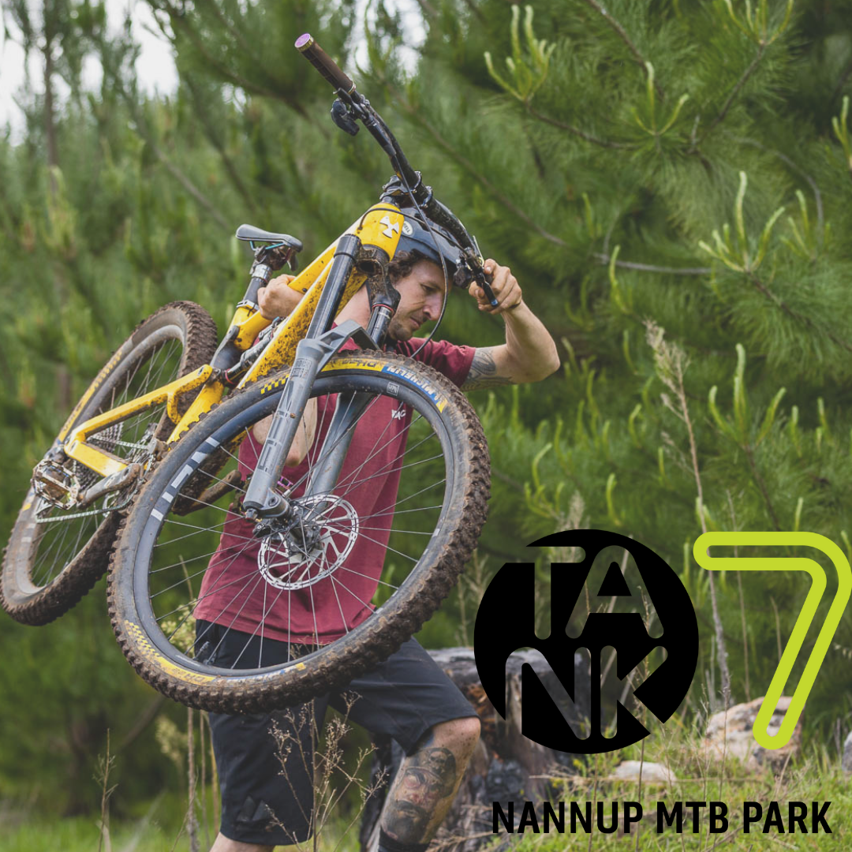

EXPRESSIONS OF INTEREST GUIDELINES OPEN FOR SUBMISSION

For more information please contact Nicole Botica on:
T: (08) 9756 1018 or E: ecdo@nannup.wa.gov.au



Contents
Part A 3
1. Overview 3
2. Stage 1. Expression of Interest 4
3. Stage 2. Request for Proposals (RFP): 4
4. Register as a Proponent 4
5. Business Opportunity 5
5.1. Target Markets 5
5.2. Licence Period 5
6. Assessment Criteria for Stage 1 – EOI 6
6.1. Proponents are Required to Address Each Criterion in Section 7.2 6
6.2. Weighted/Qualitative Objectives/Criteria 6
7. Assessment Criteria for Stage 2 – Stage 2 RFP 7
7.1. Invitation for Request for Proposal 7
7.2. Key Performance Indicators and/or Licence Conditions for Nannup Tank Mountain Bike Park 8
7.3. Close of Submissions 9
Part B 10
8. EOI Process and Assessment Methodology 10
8.1. Assessment panel 10
8.2. EOI Assessment Process 10
8.3. Selecting Preferred Proponent/s 10
8.4. Process Results and Selecting a Preferred Proponent 10
Part C 11
9. Additional Information 11
9.1. Principle 1 - Confidentiality and Conflict Of Interest 11
9.2. Principle 2 – Impartiality 11
9.3. Confidentiality 11
10. Public Liability / Workers Compensation Insurance 11
11. Local Government Procurement Policy 12
12. Advertising 12
13. Guidelines for Developing an EOI and RFP Proposal 12
13.1. Costs borne by proponent 12

Part A

Overview

The Shire of Nannup was founded in 1834. The Shire of Nannup is the second largest Shire in the South West Region with 149 kilometres of sealed and 387 kilometres of unsealed roads. The word “Nannup” comes from the Noongar people and interprets as “resting place”.

Nannup has 87% state forest within the Shire and is classified as a biodiversity hotspot with endemic vegetation and fauna. There are magnificent stands of karri, marri and jarrah forests surrounded by steep valleys and hills, there are swamp and peat pockets featuring Tea-Tree and Boronia. These hilly landscapes provide unique points of difference for cycling, which has rapidly gained popularity within the region. The Blackwood River traverses the length of the Shire and provides trail opportunities that few regions within Western Australia can realise. All of this culminates in potential for a diverse trails experience which is valued by residents and shared with visitors to the region.

Nannup is renowned for the iconic events that provide major economic stimulus for local businesses and immerse the community in social, cultural and recreational events that small regional towns rarely have access to.

The South West Mountain Bike Master Plan (SWMP) identified Nannup as a regionally significant mountain biking destination and is well regarded within the mountain bike community and provides a trail product unique to the region, attracting riders from intrastate and interstate.

The Nannup Tank 7 Mountain Bike Park features 36 kilometres of single track within the Folly Plantation and is located 2½ kilometres east of the town site.

The Shire of Nannup is seeking expressions of interest (EOI) from suitably qualified businesses or organisations to develop and operate:

- Commercial shuttle and associated services at Nannup Tank 7 Mountain Bike Park.

The Shire of Nannup in partnership with Department of Biodiversity Conservation and Attractions (DBCA), Forest Products Commission, Department of Local Government Sports Culture Industries and the Nannup Mountain Bike Club have developed the site with investment from the WA State Government (through the South West Development Commission) and the Federal Government, (through Department of Infrastructure, Transport, Regional Development & Communities). The total project investment is in excess of $1.5 million in construction of the Nannup Tank 7 Mountain Bike Park.

The park has been designed to encourage a five day stay and excite return visitation. It has been built to market and offers a unique rider experience. The park is a community asset and an attraction to the region. It is expected that in the first year of operation the park will attract an extra 10,000 visitors to Nannup.

The Shire of Nannup is advertising the commercial opportunities for operating a shuttle and associated service/s at the Tank 7 Mountain Bike Park.

The evaluation process is designed to select a business or organisation that will deliver the best management and business outcome for the Shire of Nannup. This may or may not be limited to one or more commercial providers.

Stage 1. Expression of Interest

These guidelines are for Stage 1, which seeks EOIs from interested parties. This stage will identify suitable proposals for operating shuttle and associated services at Tank 7 Mountain Bike Park which the Shire of Nannup may wish to progress.

Submissions to this EOI should provide sufficient detail to give the evaluation panel confidence that the proponent understands and has capacity to meet the criteria to a standard that will enable them to be invited to progress to Stage 2.

Stage 2. Request for Proposals (RFP):

Stage 2 will require selected proponents to submit an RFP. The RFP will require a higher level of detail on the delivery of a shuttle and associated services to deliver the best business outcome.

Proponents will need to demonstrate in their RFP submission a sustainable business model that will include detailed information on:

- how the provision of shuttle and associated services will meet the needs of locals and visitors while growing the local economy with increased visitation to the local area while protecting the natural environment;
- the target market/s as part of their business plan.

Should suitable and preferred proponent/s be identified through this RFP process, the proponent/s would be offered the opportunity to be granted a license, to enable the proposed operation/s.

The operator must be registered as a DBCA Commercial Operator. A condition of the license arrangement with the Shire of Nannup is a compulsory listing on the Experience Nannup App, www.experiencenannupwa.com.au, including the licences for the Experience Nannup brand and the Tank 7 brand.

For further information or to arrange a site visit, please contact
Nicole Botica on: T: (08) 9756 1018 or E: ecdo@nannup.wa.gov.au

Register as a Proponent

If you intend to register an EOI to this process, please email your documentation to nannup@nannup.wa.gov.au Subject: Nannup Tank 7 Mountain Bike Park Shuttle EOI.

The Applications for Stage 1 Expression of Interest Open

This document contains information about the Stage 1 EOI evaluation process. None of the information shall give rise to any promise or contract, and no legal relationship shall be created between the Shire and a proponent at any stage prior to the grant of a license.

An assessment panel will consider all EOI and RFP proposals.

Business Opportunity

We are seeking businesses or organisations to operate shuttle and associated services at Tank 7 Mountain Bike Park.

Target Markets

Whilst the Tank 7 Mountain Bike Park location has a level of existing visitation, the successful proponent will be required to identify and develop the market for their services to ensure a viable business model. This may include local and Western Australian based visitation seeking recreational opportunities as well as interstate and international visitors.

Proponents that are assessed as suitable to progress to Stage 2 - Request for Proposals will need to identify their target markets as part of their submission.

Licence Period

Proponent/s that are successful as an outcome of this EOI and subsequent Stage 2 RFP process would be offered the opportunity to be granted a licence to enable the proposed operation.

Licences provide non-exclusive authorisation to conduct shuttle and associated services at Tank 7 Mountain Bike Park managed by Shire of Nannup and include the licence to use the Experience Nannup and Tank 7 logos and branding.

The period of the licence is expected to be in the range of 2 year plus a further 2 year option, at the Shire’s discretion.

To ensure businesses continually improve towards achieving best practice, operators holding licences will be reviewed each year of the licence term against agreed benchmarks, the licence conditions and in accordance with the proposals in their EOI submissions (which will be incorporated into the licence conditions).

Licence charges would be either a per-head charge or a percentage of gross turnover. All monies received by the Shire of Nannup will be directed into maintenance of the Tank 7 mountain bike trails.

Assessment Criteria for Stage 1 – EOI

Proponents are Required to Address Each Criterion in Section 7.2

The following criteria will form the basis of the assessment and proponents must address each one in their submission to this EOI. Please address each criterion in the stated order and under the stated headings. Proponents will be scored for each of the criteria listed on a scale of zero (0) to nine (9).

Criterion for the assessment of proponent’s submissions are presented in Table 1 along with the weighting of each. Proponents are encouraged to submit relevant information to support their application.

Failure to satisfactorily address or demonstrate claims against all EOI criteria will reduce the competitiveness of the submission and may result in the application being considered non- compliant.

Proponents should assume that the Evaluation Panel has no knowledge of you, your organisation, its activities, experience or any other previous work undertaken for any organisation or government agency.

Weighted/Qualitative Objectives/Criteria

EOI Stage 1.
Proponents will be required to address all assessment criteria in Section 7.2.

Opportunity
• Shuttle and associated services servicing the Tank 7 Mountain Bike trails.

Table 1 – Weighting of criterion for proponent attributes

Criterion 1 | Proponent attributes | %  weighting
1 | Operator qualifications  Provide details of the key personnel, equipment/vehicles and demonstrate their qualifications and experience that is appropriate to managing and running the operation of the business. | 70
2 | Financial capacity  Demonstrate that you and/or the proposed operator have the financial capacity, insurance/s to deliver services and operate the proposal. | 30

Assessment Criteria for Stage 2 – Stage 2 RFP

Invitation for Request for Proposal

Proponents who are successful in this Stage 1 EOI will be invited to Stage 2. The following criterion do not need to be addressed for this Stage 1 EOI, but proponents should be aware of the requirements when making a submission.

Proponents, if invited, should ensure their RFP is consistent with their EOI submission and if changes have occurred an explanation and demonstration that these changes will not diminish the quality and sustainability of their proposal. Proponents are encouraged to submit any further information they consider may support their application.

Sub-criteria for the assessment of proponent’s submissions are presented in the table below, along with the weighting of each.

Proponents should present submissions in the same format as below if invited to Stage 2.

Table 2 - Weighting of sub-criteria for individual, business or organization operations
Criterion - Individual, business or organisation operations

Criterion | Submission requirements | %  weighting
1.1 | Shuttle and Associated Services.  Specify the range of service/s you will offer to visitors through your proposal and what will be required to undertake them, i.e. shuttle, coaching, guiding etc | 25
1.2 | Publicity  How will you maximise the opportunity to promote the Experience Nannup and Tank 7 brands. | 15
1.3 | Business operations  Provide details of management and staffing structure including licence/s and insurances held and any local employment policies. | 25
1.4 | Finance  Provide a snapshot of the financial state of the business or organisation.  . | 15
1.5 | Expenditure to local businesses.  Benefits to the local community from the proposal. | 20

Key Performance Indicators and/or Licence Conditions for Nannup Tank Mountain Bike Park

The licence(s) granted will be performance-based with key performance indicators (KPIs) or specific licence conditions made in proposals. | Content of marketing material. | - Provision of marketing material used to promote the service/s for Tank 7 Mountain Bike Park and associated brands.
 | Expenditure to local businesses. | - Commitment to local expenditure wherever possible.
 | Safety equipment and procedures. | - Appropriately trained first aid staff, first aid kit and UHF radio.
 | Visitor feedback. | - Provision of qualitative written feedback to the Shire of Nannup on services offered measured by the assessment of visitor feedback on the operation that includes some or all of the following: the perceived value for money, standard of services, number of clients across each month and rider experience at Tank 7 Mountain Bike Park.  - Feedback to be aggregated for each month

Close of Submissions

SUBMISSIONS ARE OPEN

EOI applications must be submitted to the Shire of Nannup:
Subject: Nannup Tank 7 Mountain Bike Park Shuttle EOI 2022. nannup@nannup.wa.gov.au

Part B

EOI Process and Assessment Methodology

Assessment panel

An assessment panel has been established to assess the applications and make a recommendation to the Shire of Nannup Council for approval.

EOI Assessment Process

Shire of Nannup uses a competitive process to allocate licence/s in Shire owned and managed facilities, such as the Nannup Tank 7 Mountain Bike Park.

Proponents should use their own initiative to develop applications that will meet Shire of Nannup requirements and best meet their own market needs.

During the assessment of EOI applications, all information requested in this EOI, and any relevant additional information available to the Shire of Nannup are provided by proponents in response to this EOI, may be taken into consideration.

At Shire of Nannup’s discretion, proponents may be required to clarify the application, provide further information or make a presentation to the assessment panel of information provided in an application or in relation to the selection criteria. Referees may also be contacted during the assessment process. The panel will not ask for additional information that is not specified in the EOI application.

Selecting Preferred Proponent/s

Once applications have been assessed and evaluated, an offer of preferred proponent status may then be made to the successful proponent/s.

All proposals will be given due consideration and information provided will be treated in the strictest confidence. Each proposal will be considered on its merits and if no proposals are acceptable, then none will be accepted. All proponents will be informed of their status at the completion of the approval process.

Process Results and Selecting a Preferred Proponent

Proponents will be notified of the result once formal approvals have been given by Shire of Nannup Council.

All unsuccessful proponents will be advised at the conclusion of the process and offered a debriefing on their application. Debriefings cannot include a direct comparison to any other application because all applications are treated in strict confidence except where the law requires otherwise.

Part C

Additional Information

Principle 1 - Confidentiality and Conflict Of Interest

The community and potential bidders have a right to expect that public sector staff and elected officials will perform their duties in a fair and unbiased way and that the decisions they make are not affected by self-interest or personal gain. Conflicts of interest arise when public officials are influenced, or appear to be influenced, by personal interests when doing their job (Independent Commission Against Corruption (ICAC), December 1995).

Reference is also made to the Public Sector Management Act 1994, and documents issued by the State Supply Commission relating to the terms and conditions of engagement contracts, and ethical standards in government buying.

Principle 2 – Impartiality

Individuals and organisations involved in preparing and submitting applications for public and local government sector contracts often invest considerable time, effort and resources and in return, they are entitled to expect impartial treatment at every step of the selection process.

In probity terms, procedural fairness implies a duty to act fairly and adopt fair procedures that are appropriate to the circumstances of a particular procurement/ selection process. Good administration and proper process are to be followed.

Failing to follow an open and fair selection process may lead to a loss of public confidence and the EOI and RFP being subject to judicial review – this is inevitably costly in terms of image, time and resources.

Confidentiality

The contents of proposals should not be disclosed to any outside party. Each proposal should be viewed as commercially confidential information.

Public Liability / Workers Compensation Insurance

It is a standard condition of Shire of Nannup licences that operators are covered with a minimum AU $20 million public liability insurance. It will be a requirement of the successful proponent to obtain a minimum coverage of $20 million public liability insurance for the operations before a licence/s is issued. This will need to include cover for all activities allowed by the licence/s.

Workers’ compensation insurance in accordance with the provisions of the Workers’ Compensation and Injury Management Act 1981 (WA), including cover for common law liability for an amount of not less than $50 million for any one occurrence in respect of workers of the proponent. The insurance policy must be extended to cover any claims and liability that may arise with an indemnity under section 175(2) of the Workers’ Compensation and Injury.

Local Government Procurement Policy

The Project Manager shall ensure that all decisions are in compliance with policies issued by the Local Government Procurement Policy concerning value for money aspects.

Advertising

Advertising coverage should be considered appropriate when Shire of Nannup are satisfied that the reach and penetration of advertising is sufficient to ensure appropriate market testing and that there is minimal opportunity for potential proponents to be unaware of the project.

Guidelines for Developing an EOI and RFP Proposal

It is very important that proponents provide as much relevant information in their application as possible so that the assessment panel is fully informed about the application. Proponents should assume that the Assessment Panel has no knowledge of you, your organisation, its activities, experience or any other previous work undertaken for any organisation or government agency.

Costs borne by proponent

All costs and expenses incurred by proponents in any way associated with the EOI and RFP process, the project, preparation and submission of proposals to this competitive process, will be borne entirely and exclusively by the proponents. The confidentiality of any information submitted by proponents, which is not available to the public, will be respected except where disclosure is permitted or required by law.

All proponents will be required to maintain confidentiality with respect to their own bids and should not seek details of competing bids.

